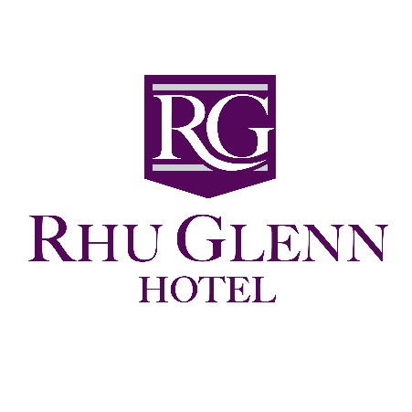

0..
Slieverue
Via Waterford
X91 E395
Tel: 051 832242
Email: info@rhuglennhotel.com / www.rhuglennhotel.com



With Compliments
Management & Staff

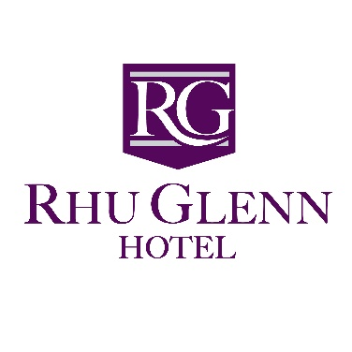

Dear future Bride & Groom,

We at the Rhu Glenn Hotel wish to thank you for considering us to help make your Wedding Day a unique & memorable one.
From your first contact with us our experienced team is on hand to guide you through every aspect of your special day.

As a Family Run Hotel, we offer you the highest quality standards together with a warm personal service. Our tranquil setting, spacious & beautifully appointed reception area is the ideal location for you to gather with your family & friends.

Enclosed for your perusal is our latest wedding package. We offer excellent value & provide top quality menus which are especially selected to suit your requirements.

We are on hand to help you with every step to making your special day a memorable one. Should you require any further assistance please do not hesitate to contact us directly on 051- 832242 or info@rhuglennhotel.com.

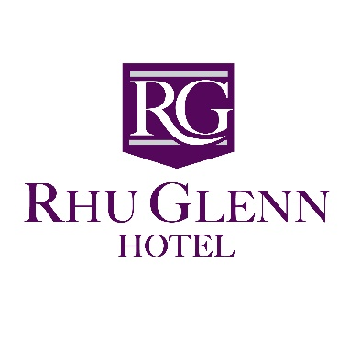

Terms & Conditions of Booking
- On booking your reception at the Rhu Glenn Hotel, we require a deposit of €500 to secure the date. This will be credited to your account. The deposit is non-refundable. However, it may be used if an alternative date is chosen. Date will only be confirmed on receipt of deposit.
- A provisional booking will be held for two weeks.
- In the event of your wedding being cancelled, a written confirmation of cancellation is required by this Hotel.
- The Rhu Glenn Hotel reserves the right to cancel a function without obligation if the booking has been made under false pretense or if a Third Party is involved.
- Confirmed menu details are required four weeks prior to your wedding reception.
- Final numbers of your wedding reception to be confirmed 1 week in advance of your wedding day. Your final payment will be based on a minimum of this amount.
- Due to the Department of Health regulations, we are unable to offer the facilities to patrons supplying their own food for consumption in the Hotel. Any beverages brought into the hotel for consumption will be subject to the appropriate corkage charge.
- Payment for your wedding reception is requested upon check out on the day after your wedding reception. We accept cash, credit cards or bank draft. Unfortunately, we are unable to accept third party cheques.
- Package prices are based on a minimum of 100 pax.

I have read and understand the above terms & conditions in full:
Client Signature: ……………………………. Date: …………………………
Hotel Signature: ……………………………. Date of Wedding: ………………….
Package: ……………………………. Price: …………………………
Deposit Amount: …………………………….
To secure a booking a copy of these terms & conditions must be signed.

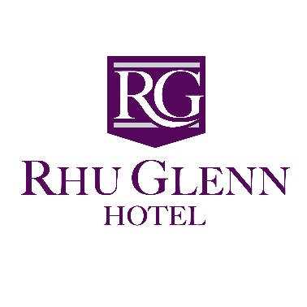

Civil Ceremonies & Partnerships

The Rhu Glenn Hotel is pleased to announce that we are licensed to hold civil and partnership wedding ceremonies.
The Hotel’s civil license means that you can both marry & celebrate your wedding reception in its beautiful & tranquil surroundings.
We can accommodate up to 120 guests in our elegant ceremony room.
If you wish to get married by civil ceremony at the Rhu Glenn Hotel you should first contact the registrar of civil marriages at the civil registration office in Kilkenny
Barbara Foley Tel No.-056-7784756

The civil and partnership ceremony package includes:
- Ceremony room dressed in floral arrangements & tea lights.
- Lantern lit red carpet arrival.
- Elegant chair covers with colour coordinated bows.
- Mood lighting (various colours available)
- Use of PA systems background music.
- Use of Tranquil Gardens for Photographs

Alternative Celebrants

Antoinette Coleman-Kelly
Registered Marriage Solemnizer
Tel: 0872482745

www.abeautifulceremony.ie
Romy McAuley Tel: 087 6622306

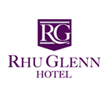

Rhu Glenn Country Club Hotel Gold Wedding Package
- Free consolation & planning with our experienced wedding coordinator
- Complimentary menu tasting for bridal couple.
- Lantern lit red carpet on arrival & complimentary prosecco for bridal party.
- Beautiful grounds for photographs
- Use of our large reception area to greet guests.
- Tea, coffee & fresh scones for all your wedding guests on arrival
- Complimentary hire of our charming Function Room
- Dedicated Banqueting Manager to supervise and coordinate your Reception.
- Elegant chair covers with colour coordinated bows.
- White Table Linen with Floral Arrangements and Cloth Napkins
- Mood lighting (various colours available) plus elegant fairy light back-drop
- Children are welcomed and special menus are available.
- Alternative options for special dietary requirements and vegetarian options are available.
- Cake Stand and knife
- Microphone & PA system for toastmaster & speeches
- Evening refreshments for all dinner guests
- Complimentary accommodation for Bride & Groom
- All rooms at special reduced rates for wedding guests
- Discount for weddingfairsonline.ie
- Discount for deiseweddings.com (sparkling dancefloor, magic mirror, large love sign)

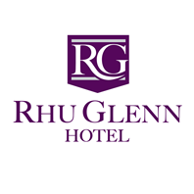

Rhu Glenn Country Club Hotel Platinum Wedding Package
- Free consolation & planning with our experienced wedding coordinator
- Complimentary menu tasting for bridal couple.
- Lantern lit red carpet on arrival & complimentary prosecco for all guests.
- Beautiful grounds for photographs
- Use of our large reception area to greet guests.
- Tea, coffee & fresh scones for all your wedding guests on arrival
- Complimentary hire of our charming ballroom
- Dedicated banqueting manager to supervise and coordinate your reception.
- Elegant chair covers with colour coordinated bows.
- White table linen with floral arrangements and cloth napkins
- Mood lighting (various colours available) plus elegant fairy light back-drop
- Children are welcomed and special menus are available.
- Alternative options for special dietary requirements and vegetarian options are available.
- 3 Glasses of Wine per guest during meal
- Cake Stand and knife
- Microphone & PA system for toastmaster * speeches
- Evening refreshments for all dinner guest
- Complimentary accommodation for Bride & Groom
- Complimentary accommodation for Chief Bridesmaid & Best man
- All rooms at special reduced rates for wedding guests
- Complimentary 1st year anniversary night stay & a 3 course dinner
- Discount for weddingfairsonline.ie
- Discount for deiseweddings.com (sparkling dancefloor, magic mirror, large love sign)

Wedding Guest Accommodation Packages

We have 31 guest rooms here at the Rhu Glenn Hotel, we offer each of our couples the option to block book these rooms for their guests when the wedding is being booked (Subject to availability when booking)

We offer our wedding guests the following rates:

1 Night Accommodation with Full Irish Breakfast
€75.00 per person sharing.

2 Night’s Accommodation with Full Irish Breakfast
€65.00 per person sharing per night.

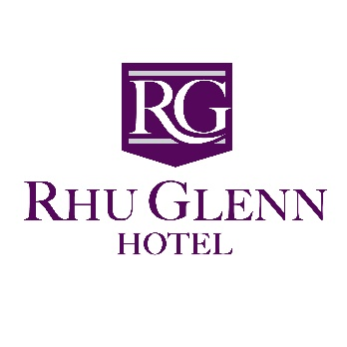
Sample Wedding Menu 1
~Soup~
Cream of Vegetable Soup
*******
~Main Course~
Roast Stuffed Chicken & Baked Ham with a Sage Jus

Served with a Selection of Vegetables & Potatoes
*******
~Dessert~
Black Forest Gateaux
*******
Freshly Brewed Tea or Coffee
€52.00 per person Gold
€64.00 per person Platinum
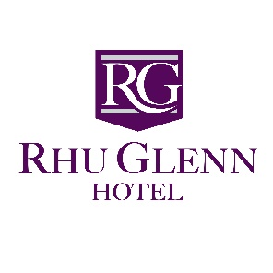
Sample Wedding Menu 2
~Starter~
Smoked Chicken Salad
Topped with Roast Pine Kernels and Tarragon Vinaigrette
*******
~Soup~
Cream of Mushroom Soup
*******
~Main Course~
Traditional Roast Stuffed Turkey & Baked Ham
Served with a Port & Cranberry Jus
Or
Poached Darne of Salmon
Served with a White Wine & Cream of Fondant
Served with a Selection of Vegetables & Potatoes
*******
~Dessert~
Homemade Blackberry & Apple Pie
Served with Custard & Cream
*******
Freshly Brewed Tea or Coffee
€54.50 per person Gold
€66.50 per person Platinum
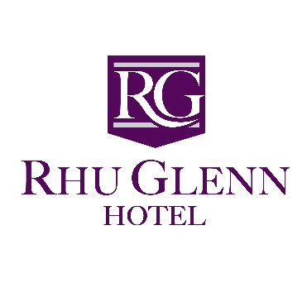
Sample Wedding Menu 3
~Starter~
Chicken & Mushroom Vol-au-Vent
*******
~Soup~
Leek & Potato Soup
*******
~Main Course~
Roast Sirloin of Beef
Served with a Red Wine Jus
Or
Supreme of Chicken Pascale
With a Potato & Herb stuffing

Served with a Selection of Vegetables & Potatoes
*******
~Dessert~
Rhu Glenn Dessert Platter
*******
Freshly Brewed Tea or Coffee
€57.00 per person Gold
€69.00 per person Platinum

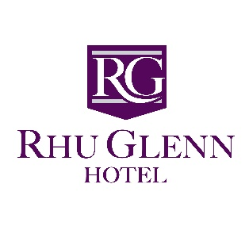
Wedding Menu Planner

Starters
Free Range Egg Mayonnaise with Seasonal Salads
Melon & Pineapple Ensemble with Fresh Garden Mint
Smoked Chicken Salad, topped with Roast Pine Kernels and Tarragon Vinaigrette
Creamed Chicken & Mushroom Vol-au-Vent
Oven Baked Chicken Wings placed on a sorrel of Lettuce, tossed in a Sweet Chili Sauce
Warm Black Pudding Salad enhanced with smoked Lardons of Bacon accompanied with Bramley Apple Chutney
Spicy Cajun Chicken Salad served with a red onion and chili salsa.
Seafood Cocktail, Selection of Fresh Fish layered on Crispy young Lettuce Leaves & drizzled with Marie Rose Sauce
Mushroom Napolean served en-cruet with a Rich Brandy and Pate Sauce

Vegetable Samosas & Spring Roll shallow fried ‘till golden & topped with soy & teriyaki Sauce.

Soup

Cream of Tomato Soup

Cream of Vegetable Soup

Cream of Mushroom Soup

Chicken & Sweetcorn Soup

Leek & Potato Soup

Smoked Bacon & Courgette Soup

Kilmore Quay Seafood Chowder

Sorbet
Lemon Fresh

Tropical Orange

Champagne

Mango & Passion Fruit

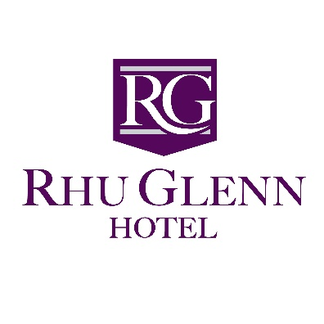
Main Course
Supreme of Chicken Pascal with Potato & Herb stuffing, wrapped in Bacon, served with a Creamy Whiskey & Mushroom Sauce

Roast Stuffed Chicken & Baked Ham served with a Sage Jus.

Supreme of Chicken Stuffed with a Chorizo & Mozzarella served with a Creamy Mushroom & Brandy Sauce

Traditional Crown Turkey and Baked Ham served with a Port & Cranberry Jus

Roast Loin of Pork with Apricot & Herb Stuffing served with a Calvados & Apple Sauce
Prime Roast Sirloin of Beef served with Yorkshire pudding and Horseradish Sauce.
Seasonal Price

Slow Cooked Lamb Shank with Rosemary Stuffing served with a mature mint Sauce.
Seasonal Price

Slow Cooked Featherblade of Beef served on a Bed of Champ Potatoes with a Pearl Onion & red Wine Jus.

Honey Glazed Ham served with Pineapple Slice and Madeira Sauce

Poached Escalope of Fresh Salmon on a bed of Spinach served with a White Wine & Crème Fondant or a Fresh Béarnaise Sauce

Duo of Salmon & Cod, White Wine poached and coated in a Mornay & Mustard Sauce

Fillets of Lemon Sole, lightly seasoned with Dill or Fresh Prawns topped with a Mornay Sauce & Gratinated
Oven Baked Fillet of Hake with a Lemon & Herb Crust served with a Red Pepper & Citrus cream Sauce.
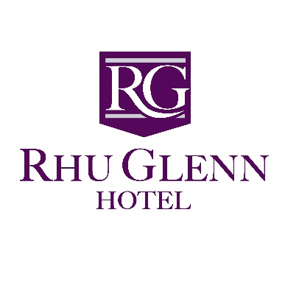

Vegetarian Main Course
Selection of Stir-Fried Vegetables served with Pilaff Rice

Tuscan Style Linguini, Creamy Sundried Tomato & Roast Peppers
A light Fine Herb Crepe filled with a Strudel of Vegetables on a bed of Tomato & Basil Coulis

Penne Pasta, Spinach & Sun-Dried Tomato in a Crème Fondant

Pasta Pappardelle, freshly cooked Pappardelle tossed with Garlic, Tomato, Peppers, Onions & Courgettes finished with a Tomato & Fresh Herb Sauce
Italian Vegetarian Tortellini
Pouches of pasta stuffed with ricotta cheese and spinach finished with a creamy spring onion sauce.

Wedding Menu Desserts
Homemade Blackberry & Apple Crumble served with Crème Anglaise.
Black Forest Gateaux & Fresh Dairy Cream
Oven Fresh Apple Pie & Fresh Dairy Cream
Fresh Fruit Meringue Nests & Fresh Dairy Cream
Chocolate Wafer Basket filled with Strawberries & topped with Cream.
Carte Dòr Ice Cream
Fresh Fruit Salad & Ice Cream
Traditional Fruit Trifle & Custard
Profiteroles with Chocolate Sauce & Fresh Dairy Cream
Fresh Carrot Cake & Almond Cream
Selection of Homemade Cheesecakes
Rhu Glenn Hotel Special Dessert Platter (Create your own)

Freshly Brewed Tea or Rich Roast Coffee

Testimonials
“My husband and I got married the 9th September 2016 in The Rhu Glenn Country Club Hotel. Around 18 months before we looked at a view venues but nothing jumped out at us. I remember the day we had our appointment to meet with John (Rhu Glenn Events Manager) it was a warm day and as soon as we walked in we were met by a warm cosy atmosphere. We were exceptionally happy that we paid our deposit then and there and drove home beaming that we had made a start to our plans. Time quickly flew in and plans were in action. Every single time I contacted John regarding the venue his reply was "We have that sorted lads don't worry". To say we didn't have one thing to sort out for the venue was an understatement; they covered everything, and were happy to help with any little extras I had planned. Our day arrived and it was raining from the minute I woke up. It didn't put a damper on us though and we started with preparations with smiles from ear to ear. We arrived at The Rhu Glenn after the ceremony and were greeted by John and staff at the door with massive umbrellas. That was the start of our amazing day here. As soon as we walked in we were met by our guests, music playing in the corner and a champagne reception and just as we remembered 18 months prior a warm cosy atmosphere. Our guests were given their rooms without delay as everyone was soaked and needed to freshen up. The moment we walked in to the function room we were blown away. Everything we imagined and more. John and the staff went over and beyond to make our special day "Special.. Everything went down perfectly and I remember someone saying that it was the most relaxed wedding they were ever at. I was so relaxed and comfortable to leave everything in the hands of John that I did not have one worry the whole night. We had 16 people at our top table and john made it look amazing and fit everyone on it comfortably. When the speeches were over, we had our amazing 5 course meal. From start to finish we could not fault it. And nobody else could either. I'm still hearing about the amazing soup from our guests. We danced the night away and it was over so so fast. I remember walking out to the reception area at the end of the night and john was phoning for taxis for the guests that lived near and wasn't staying over. He made sure everyone was accommodated. We had the most amazing sleep in the honeymoon suite. All of a sudden it was morning time and we were walking up to get our breakfast. The staff were amazing and we were met by a smiling, happy, bubbly waitress who asked all about our big day and was genuinely interested in how it went. We then went on to have our breakfast, even though we had rough bellies from the night before (haha) we couldn't put our forks down. We went to the receptionist and thanked her for everything they done for us and explained how magical it all was. She told us to take our time that there was no rush in leaving our room. Everything from start to finish was magical. We could not fault it and either could our guests. We would highly recommend The Rhu Glenn Hotel for any functions. We will most definitely be returning for our 1 year anniversary. All the best in the future. Leann & Alan.” Leann & Alan Flavin (September 2016)

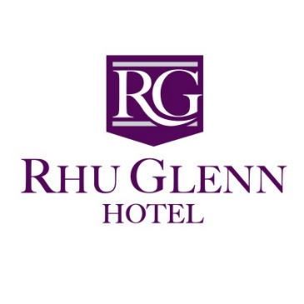

“What a lovely place.. John and his staff were so helpful and understanding for my new Wife Amanda and myself.. the food on top class the venue was amazing.. he made our special day on the 9th July for our wedding..
I have and will be recommending to everyone what a lovely place to have a wedding.. couldn't been any better”.. Amanda & John Butler (July 2022)

“We had our wedding here last Friday the 15th July and could not fault anything at all John and the staff were so accommodating to ourselves an all our guests
The service was exceptional and the food was amazing
From start to finish even with planning John couldn’t be any more helpful to us made planning the wedding at the hotel so much easier
John and the staff went above and beyond and made the day go without any issues”
Kelly & Lee O Brien (July 2022)

“We had the pleasure of celebrating our wedding in the Rhu Glenn on the 17th June this year. We could not have been happier with the way everything turned out, right from the start John (the hotel manager) made us feel very welcome ensuring every detail was perfect no matter how big or small, we cannot thank him enough. The hotel staff were very friendly and helpful they went above and beyond to make sure we had a fantastic day. The food was delicious, piping hot and served very quickly. We would highly recommend the Rhu Glenn for your wedding reception or any social event you won't be disappointed. I just wish we could do it all over again it really was the best day of our lives!” – Denise & Patrick Roche (June 2017)

“Got married here on New Year’s Eve and couldn't fault a thing! John was brilliant throughout the whole day and the time leading up to it. I didn't have to worry about a thing! All our guests commented on how well the day flowed and everything from the ceremony to drinks reception to the evening was faultless. The food was amazing! Would recommend the Rhu Glenn Hotel to anyone considering it as their wedding venue they will not pick a better hotel! Thanks again to John and staff it was a pleasure!” – Andrew & Tara Murphy (December 2017)

Local Bed & Breakfast Accommodation List

Diamond Hill Guesthouse – 051 832855
Grannagh Castle B&B – 051 844642
Claddagh B & B – 051 854797
Asling B&B – 051 895456
Belmont House – 051 8322174
Catherine Grant “Spa Cottage” – 086 1954616

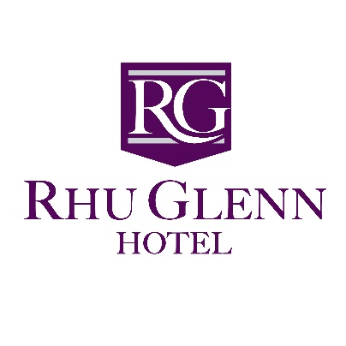

Wedding Suppliers
Florists
All about Flowers- Tara Freyne- Slieverue via Waterford 051-832028
Flowers Unlimited- New Ross, Wexford 051-421692

Jewelers
Forristal`s- South Street, New Ross 051-421458
Brooks Charles- Street, New Ross 051-421905

Travel Agent
Harvey Travel- Gladstone Street, Waterford 051-872048
Hilary Murphy- New Ross, Wexford 051-421629

Bridal Wear
All About Eve- Parnell Street, Waterford 051-870733
Eden Manor Bridal Rooms- Clohass, Enniscorthy, Co. Wexford 0539232586

Mens Wear
Fitzgeralds Menswear- Waterford 051- 875297
Charles Pierce Menswear- Wexford 053-9122792

Piper
Robbie Donovan- 087-4166044

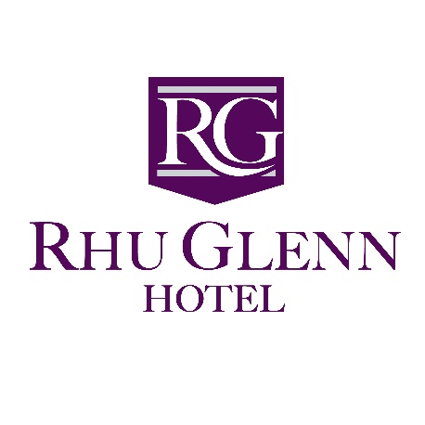

Hairdressers
Albert’s Hair Design- New Ross, Wexford 051-448818
Empire Hair- Waterford 051-323584
Shades- Ferrybank, Waterford 051-851555
The Jolly Barber- Ferrybank, Waterford 051-871376

Photographer
Mary Brown Photography- New Ross, Wexford 051-421763
Golden Moments Photography - Alan Golden- Faithlegg, Waterford 085-1975717
Mary Atkins Photography- Wexford 087-9417456
Wexford Wedding Photography- Des Kiley- Wexford 086 8231727

Videographer
Denis Cadigan- Campile, New Ross, Wexford 051-388352

Confectionary
The Cake Lady Catherine Kent- Mullinavat, Kilkenny 0876681164
2 Nice 2 Slice- Tullahought, Windgap, Kilkenny 085-8085844

Stationary
Wedding Creations- Tomhaggard, Wexford 087-4513731
Designs by Eefaa- Waterford 083-8355597

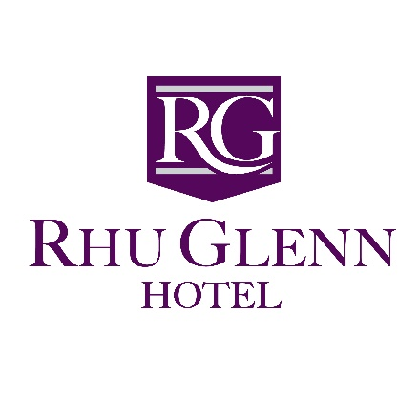

Entertainment Sheet
Bands
Bentley Boys Band – 086-7744838
The Irish Rat Pack – 086-2609819
Brass & Co – 051-381120
Seattle – Eddie – 087-2216554
Loose Cannons- 087 9567446
Suzie Q – 085 7765556
Wrecking Ball – 087 6065600
DJ
Liam O Connor 086-1590976
John O’Shea 087-6265485
Maurice Flynn 0876756862
Wedding Extras
Deise Weddings (sparkling dancefloor, photobooth, love letter) Waterford 0861590976
The Singing Chef- Brendan Waterford 0879002027
Transport
Limo Hire – Richard- 0894545210

